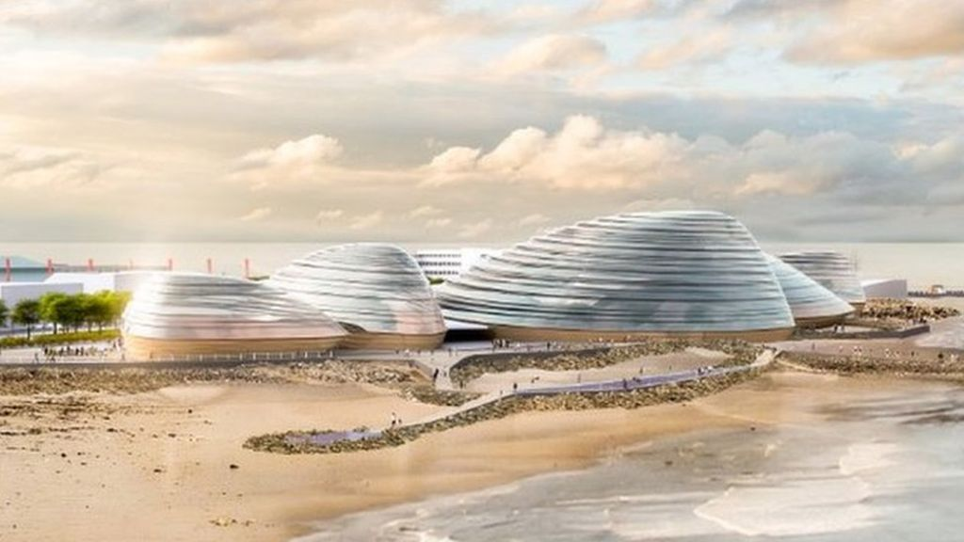
EDEN PROJECT NORTH

On Thursday 9th January, I had an amazing opportunity to participate in discussions about the new Eden Project which is going to be built in Morecambe over the coming years. I was dropped off at Lancaster and Morecambe College where I met children from other local primary schools and staff from LMC. We were taken to a conference room and we spent the afternoon discussing the curriculum that the Eden Project North will provide.
First of all, we had to complete a quiz all about our school curriculum. I was very positive about ours, because our curriculum is very interesting.
Next, we had to draw a picture of an influential person, for example, Greta Thunberg. I chose Martin Luther King.
After that we had to work out which way was north, east, south and west in the room that we were in. Once we had worked that out, we had five questions to answer about our preferred style of working with four options to choose from, one at each cardinal point in the room. An example question was:
How do you like working?
N = watching
E = Writing
S = Doing
W = Listening
Our last task was to sort out the 17 UN Sustainable Development Goals into a diamond diagram of most important to least important, in our opinion. Our contributions will be used to help the Eden Project staff to develop a curriculum for local school pupils to learn from.

I really enjoyed the day and am looking forward to the next meeting!

Joel, Year 6.

